State of Fluid & Origin: High sediment, clarifier wastewater originating from river basin

Client Expectations: Significant reduction of Total Suspended Solids to improve efficiency on their existing equipment, mainly a filter press and clarifier.

The process: We ran a single pass of the fluid through our test torpedo which is exactly ¼ scale of the commercial torpedoes on the ARC 2.0; there are 4 torpedoes on each commercial skid. After treatment, the samples were given a retention time of 5 minutes for solids to de-emulsify and settle. After 5 minutes, a clean ¼” vinyl tube was used to syphon the water off the top of the sample. The treated and syphoned water was then immediately sent to 3rd party testing facilities, along with a control sample for comparisons.

MWCI is extremely committed to proper testing protocols; therefore, The ¼ scale unit, pump and system is flushed with new distilled water and new hoses are used prior to each test.
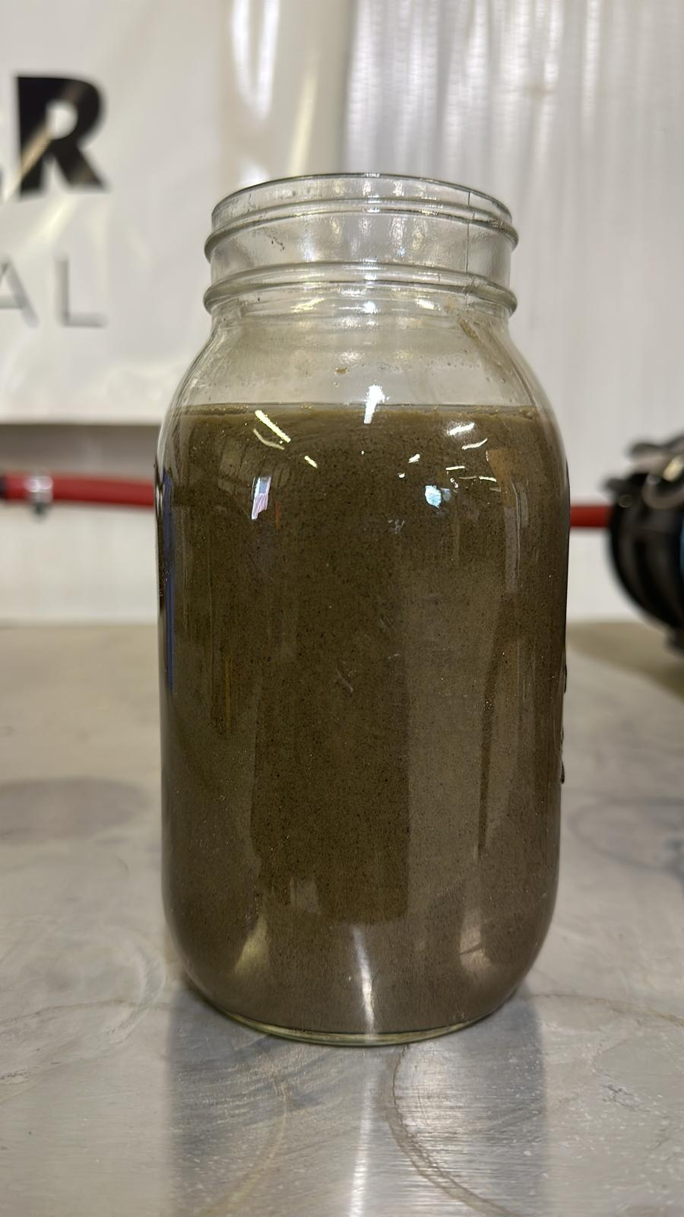
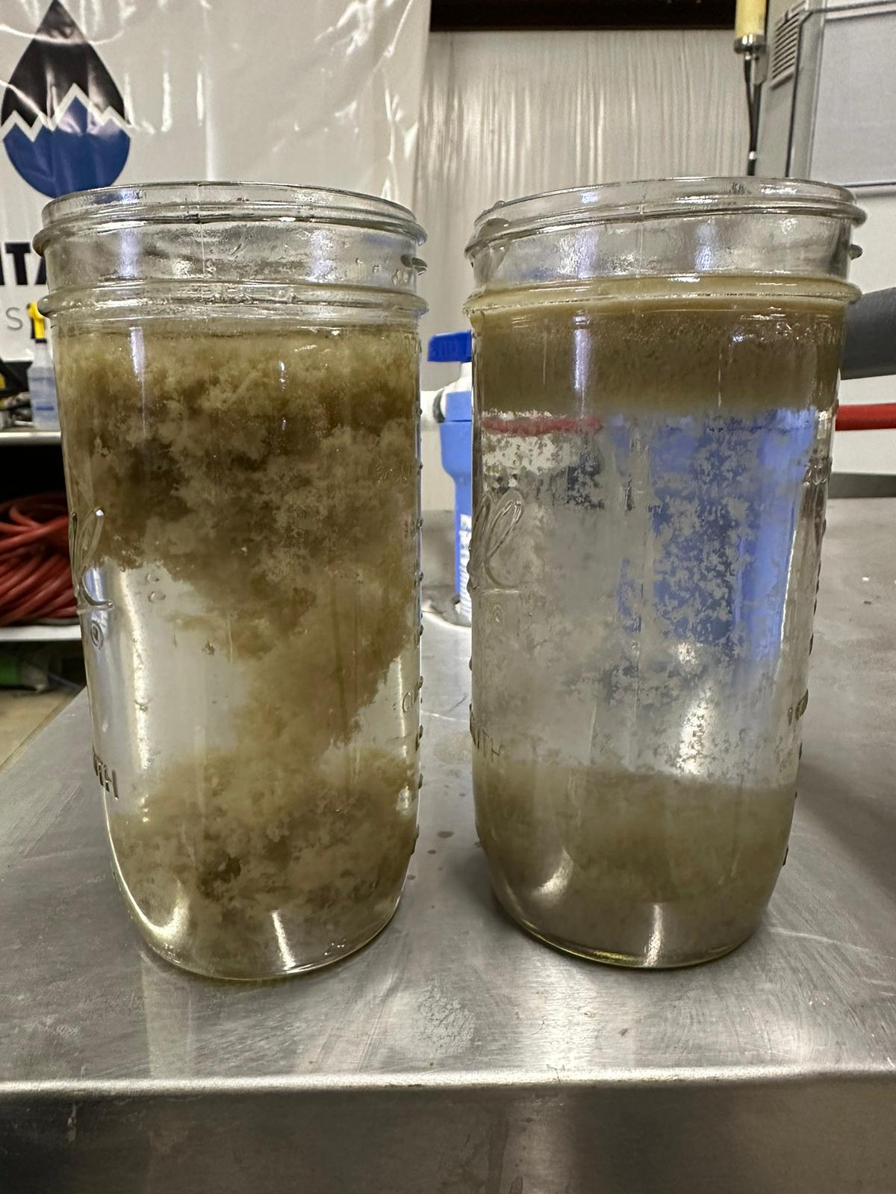

Control – directly from client’s source
A couple minutes after treatment as solids begin to coagulate and settle

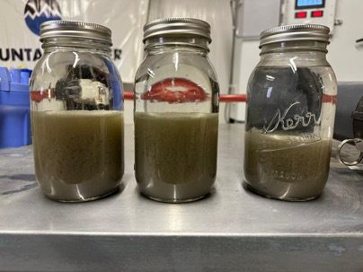

Final stage – after 5 minutes of de-emulsifying and settling

The Results: The results indicated almost a complete removal of Total Suspended Solids at a 99.998% reduction.

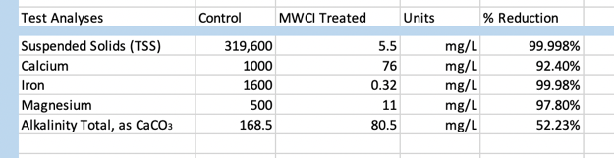

In addition to testing for Total Suspended Solids, we tested for a few heavy metals the client was also curious about. As you can see from the results above, these metals were also substantially reduced, between 92% and 99% removal of metals from the water.

The client’s expectations on this project were to reduce the suspended solids their secondary equipment needed to treat. With these test results, we can say with great confidence their secondary equipment will be quite unburdened.

