Colorado Mining Discharge Water

State of fluid: The untreated waste stream created from the mining practices associated with gold and silver mining operations. Total dissolved solids (TDS) originally measured 1300ppm.

Expectations: Client expectations are the removal or reduction of minerals, metals and solids to meet or exceed all compliance provisions of the Colorado water control act for discharge to both surface and groundwaters, in conjunction with the federal water pollution control act.

Process: A single pass through the ARC unit for testing and sampling purposes. A secondary mechanical separation was also observed by use of centrifuge.

Results: The initial testing comprised of measuring TDS from the control, the ARC unit only, and the ARC unit and centrifuge process. The TDS of the control was 1300ppm. The ARC unit’s immediate reduction of this TDS was a 53% reduction, with the measurement at 613ppm.

The ARC unit and centrifuge combined process yielded 423ppm, a 68% reduction of TDS. Additional settling time beyond 24 hours further reduced the TDS to 313ppm.

The clear water on the left of each picture is taken directly from the mine as a control. The control has a turbidity of 0, however as the tests indicate there are 1300ppm of TDS in the water. The jar on the right of each picture is the treated water before and after gravity settling.

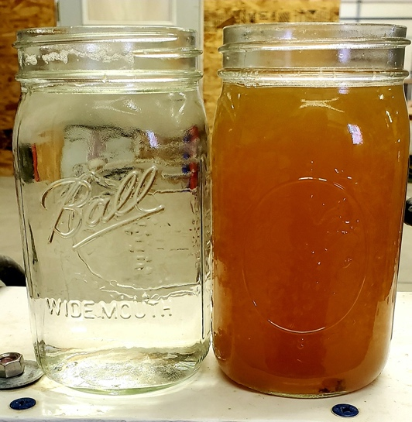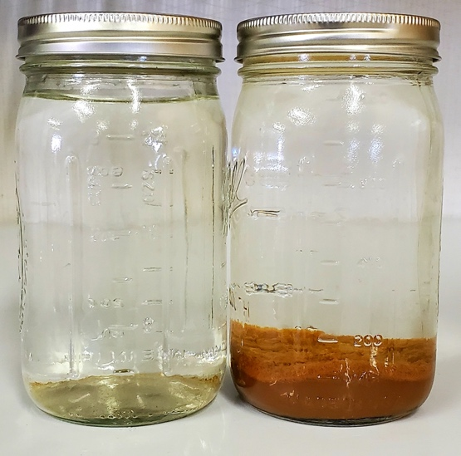
Two control samples were taken, one consisting of the original fluid and the second sample consisting of the mixture of settled solids.

1) We were able to achieve a reduction in the following elements from the original fluid.

33.3% reduction in Calcium (Ca)
98.2% reduction in Copper (Cu)
95.7% reduction in Iron (Fe)
28.1% reduction in Magnesium (Mg)
50% reduction in Manganese (Mn)
48.1% reduction in Zinc (Zn)

All levels achieved are within the discharge parameters for direct disposal to surface and groundwaters as per state and federal law.

2) The leftover matrix of the solids removed by the ARC consisted of:

Calcium: 24,000 mg/Kg-dry
Iron: 150,000 mg/Kg-dry
Magnesium: 8,900 mg/Kg-dry
Manganese: 3,500 mg/Kg-dry
Sodium: 22,000 mg/Kg-dry
Zinc: 8,900 mg/Kg-dry
Copper: 2,200mg/Kg-dry

The removal of 2200mg/kg-dry copper can be separated from the leftover solids to recapture and sell the copper for a new and previously unrealized increase in revenue.

As a raw example, 2200mg/kg of copper is equivalent to ~12oz of copper in every barrel of mine wastewater that can be captured.

The raw current price of copper/oz is ~ $0.18, * 12oz/bbl = $2.16/bbl

A single ARC unit processing 3500bbl/day of mine wastewater * $2.16/bbl = $7560/day

The recapture of copper and potentially other precious metals within mining waste streams will significantly decrease the cost of wastewater processing and potentially turn an expense into positive revenue.

