Location

Deer Creek Facility Whitewater south of Grand Junction, Colorado. Two large evaporation ponds comprised of both produced and drilling water.

Client Requirements

Facility requirements were to significantly improve turbidity in order to allow and maximize UV Penetration for evaporation, and to reduce odor from the ponds.

Test Results

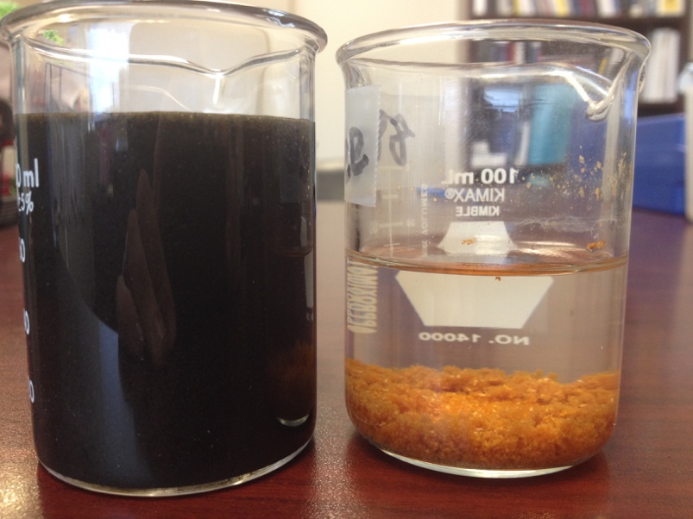
Cleaned Sample through Arc Unit
Control Sample from Pond

Measurement of the total suspended solids in the Control measured 11090 mg/litre.

Measurement of the total suspended solids Avg. of the 3 tested samples 436 mg/litre.

This equates to a 10,654 mg /litre reduction in TDS or a 96% reduction overall.

The photo above clearly depicts the turbidity of the pond water starting extraordinarily dark, even the lab had difficulty measuring the initial turbidity because it was too dark. Therefore, a diluted sample of 100x was added to get an initial reading of turbidity.

NTU = Nephelometric Turbidity Units – Measures the intensity of light scattered at 90 degrees as a beam of light passes through a fluid sample.

The 100x sample for turbidity was measured at rate of 1,910 NTU x100 = 191,000 NTU

The non-diluted, cleaned Arc Sample water registered at an average of 316 NTU

The visual reduction in turbidity is astounding, additionally the measured result of reduction of <99% speaks volumes to the performance of the Arc Unit.

Conclusion

All of these results were accomplished with a single pass through the Arc unit. Increased results as needed are easily accomplished via recycle protocols, and/or additional units calibrated to meet specific client criteria.

