Location

Benzel Facility out of Rifle, Colorado. 500-barrel Uprights. Produced water storage facility

MWCI processing of oilfield production water

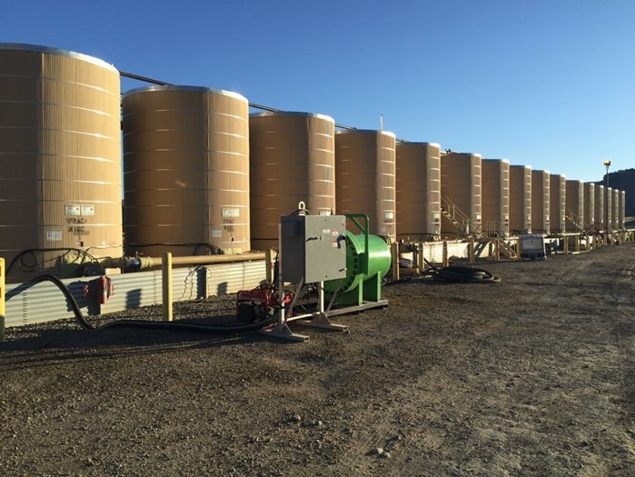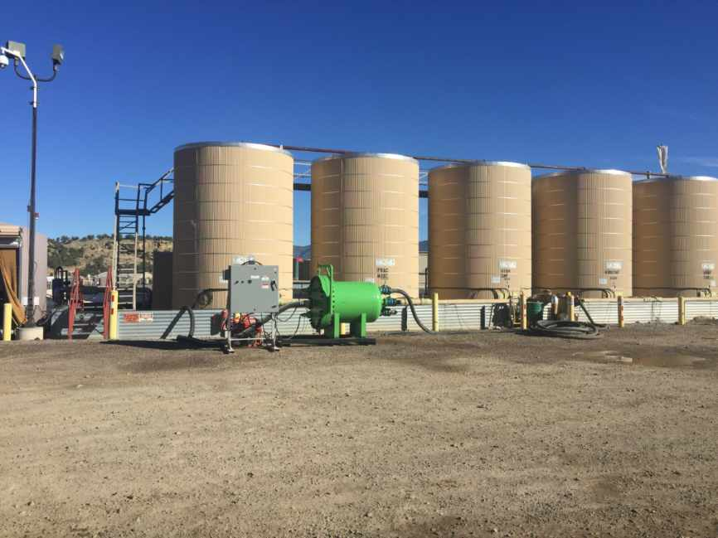

Project Details

A single Arc Unit was brought on site to process 16 full uprights of produced water, a single on-site empty upright served as the first vessel for the effluent water. The uprights were cycled one by one having the newly processed effluent water discharged into the most recently emptied tank. A simple manifold system was utilized to switch between tanks.

Financial Considerations

Each upright carried a disposal cost of $20.00 per barrel which included the direct disposal costs as well as the trucking expense, the total disposal cost per 500-barrel tank was $10,000 per upright. With 16 uprights to be disposed the total project cost for disposal was $160,000.

Application of Financial Model

Do to our unique and proprietary technology the Arc unit was separating and cleaning an average of 10% previously lost oil asset from each upright for a total avg volume of 50 barrels per upright. Originally this material was part of the overall disposal which was costing the company $1000.00 per upright. However, the Arc Unit separated and cleaned the oil from the base fluid making it easily recoverable via simple syphon process.

50 Barrels of cleaned and recovered oil per upright at $50 per barrel creates $2500 per upright positive offset in price of disposal. Plus reducing the volume of disposed material by 50 barrels equates to an additional $1000.00 in savings.

The added benefit of the oil recovery is secondary to the Arc Units ability to kill bacteria and drastically reduce solids, contaminants and impurities commonly known as (TSS) Total suspended solids and (TDS) Total dissolved solids. Both visually and lab measurements indicate an additional 70% recovery rate of reusable water from the base material. The TSS and TDS gravity settled to the bottom in both the uprights and sample containers. By removing the 10% clean oil as well as the 70% reusable water the remaining amount of base material that requires disposal is only 20%.

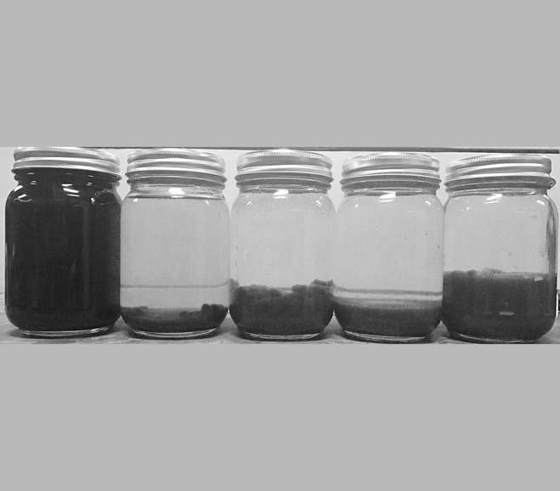
Original base material
Fully settled sample
Treated stages with only gravity settling

Reducing the disposal by an additional 70% equates to 350 barrels at $20.00 per barrel for a savings of $7000.00 per individual upright.

The 80% reduction in disposal water was accomplished with a single pass through the Arc Unit at a rate of 125 gallons per minute and utilized less than 150 watts per hour.

Financial Conclusion

The net math for each upright is as follows:

Original cost of Disposal ($10,000)
Reduction of 50 barrels to disposal $1,000
Reduction of 350 barrels of cleaned reusable water $7,000
Total cost of the remaining 100 barrels to disposal ($2,000)
Recaptured clean oil asset 50 barrels x $50/barrel $2,500

Total gross revenue per upright $500
Total Savings per upright $10,500
Total Savings for the 16 upright project $168,000

Summary Statement

What is the value of MWCI technology when we provide an 105% reduction for your companies produced water disposal costs?

